Lab 1

William Wright

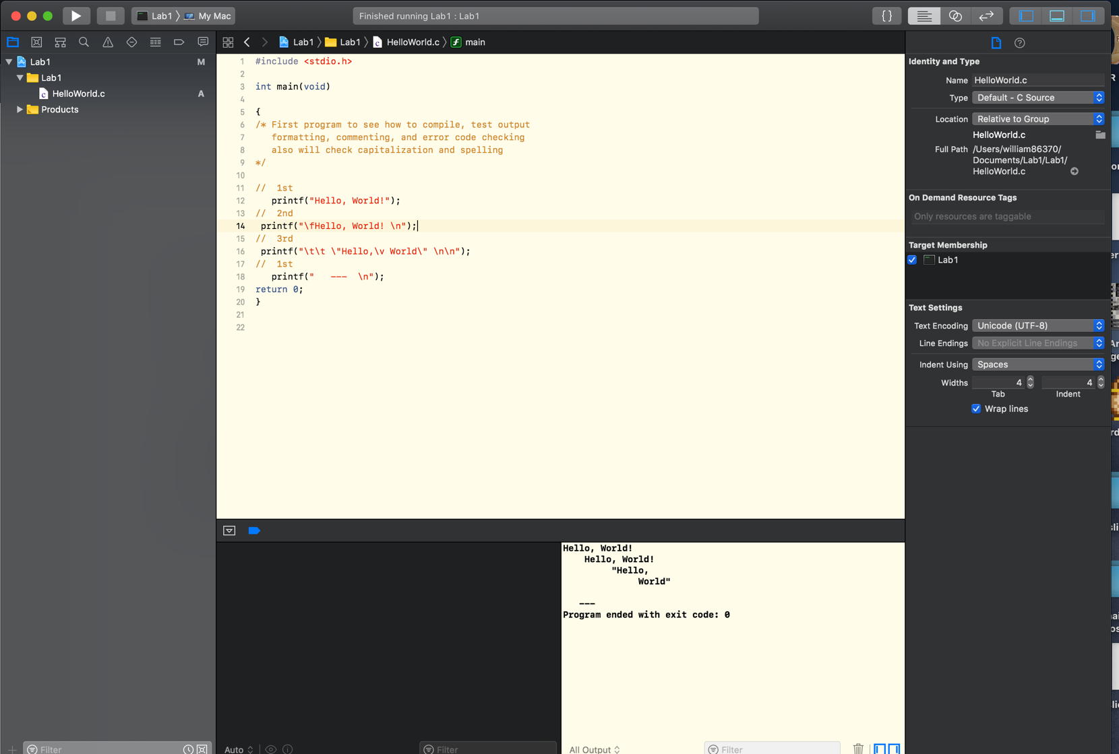I used Xcode for my IDE because xcode is God-Tier

Here is the hello world running in command prompt below the code window

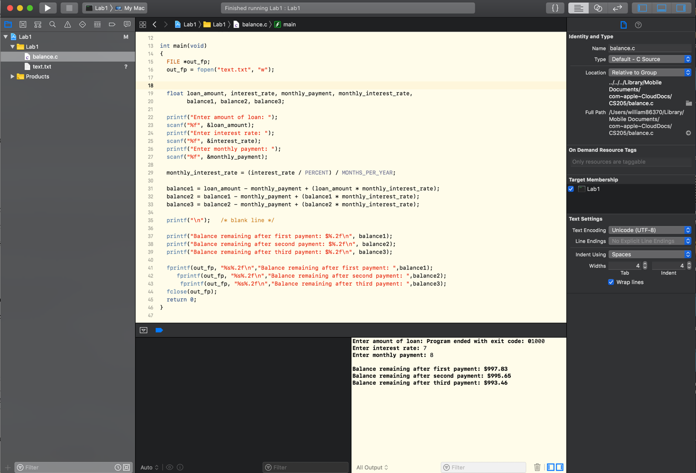

The photo above is the balance.c class running with my desired output

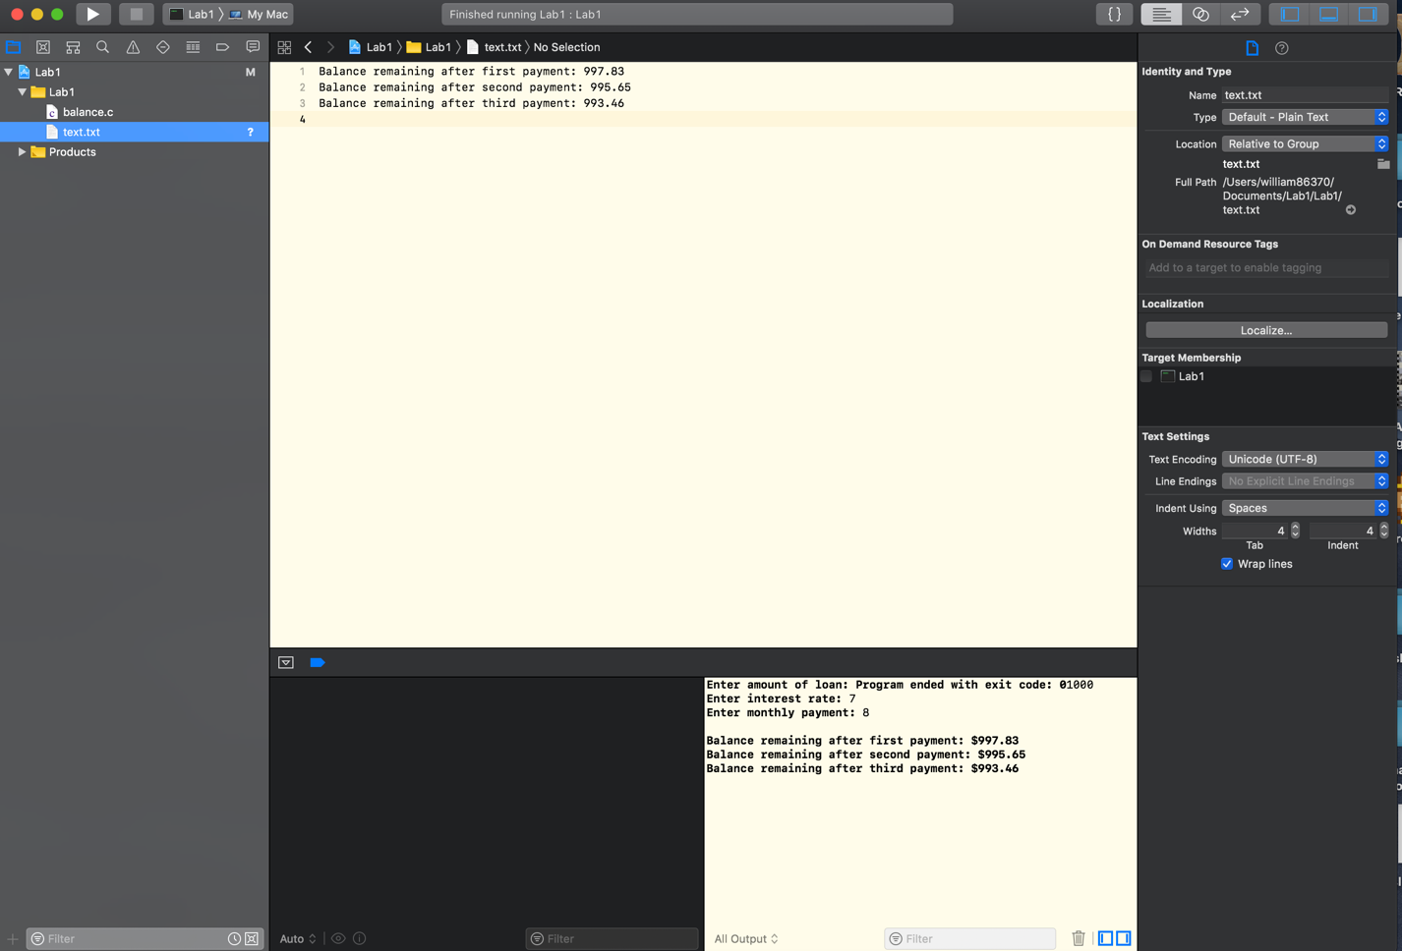

the photo above is my text document it created writing the same output as the terminal

* Describe what we did and your results for the above

In this lab we used a class that lets you calculate payments based on a load the user enters, we also write the data to a text document.

* Any issues with the above?

The attached code didn’t really tell me how to write using c, I only know c with Arduino so I mainly write to serial but it was a quick google search to learn how to use %s for string and %f.02 to write a float with 2 decimal places.